**LINUX - ASSIGNMENT**

**Assignment 1:**

● When we create a user, some hidden files are generated in the directory of the same user at that time. How is it done?

In [computing](https://en.wikipedia.org/wiki/Computing), a **hidden folder** (sometimes **hidden directory**) or **hidden file** is a [folder](https://en.wikipedia.org/wiki/Folder_(computing)) or [file](https://en.wikipedia.org/wiki/Computer_file) which [file system](https://en.wikipedia.org/wiki/Filesystem) utilities do not display by default when showing a [directory](https://en.wikipedia.org/wiki/Directory_(computing)) listing. They are commonly used for storing user preferences or preserving the state of a utility, and are frequently created implicitly by using various utilities. They are not a security mechanism because access is not restricted - usually the intent is simply to not "clutter" the display of the contents of a directory listing with files the user did not directly create.

To view **hidden files**, run the ls **command** with the -a flag which enables viewing of all **files** in a **directory** or -al flag for long **listing**.

● Make subdirectories inside a parent directory by using single mkdir command (refer figure given below)



Command : mkdir –p A/B/C

● tac command vs cat command

**Cat** command(**Concatenate)**, is one of the most used commands in linux systems. The most basic usage of the command is to read files and display content of files on the terminal. Another usage of the **cat** command is to read or combine multiple files together and send the output to a monitor screen.

On the other hand, a lesser used command in linux systems is tac command. **Tac** is practically the reverse version of cat command (also spelled backwards) which prints each line of a file starting from the bottom line and finishing on the top line to your machine standard output.

**Assignment 2**

● Change the Umask value for any user permanently.

We can change the umask value both temporarily and permanently.

To permanently set the new value system-wide open the **/etc/profile** file with your text editor:

sudo nano /etc/profile

and change or add the following line at the beginning of the file:

in /etc/profile perform:

umask 027

For changes to take effect run the following **source** command or logout and log in:

source /etc/profile

To verify the new settings we will create one new file and directory using [**mkdir**](https://linuxize.com/post/how-to-create-directories-in-linux-with-the-mkdir-command/) and [**touch**](https://linuxize.com/post/linux-touch-command/):

mkdir newdirtouch newfile

you can see the changes using ls command.

● Add a new user without using adduser & useradd command

Steps to add a user to a system without using useradd/adduser*?*

* Add an entry for the user in /etc/passwd file.
* Add an entry for the group in /etc/group file.
* Create the home directory for the added user.
* Set the new user password using the passwd command.

● Can we change the Umask value to 0888.

○ If yes, then how. If not then why ?

No we cannot change the umask to 0888.

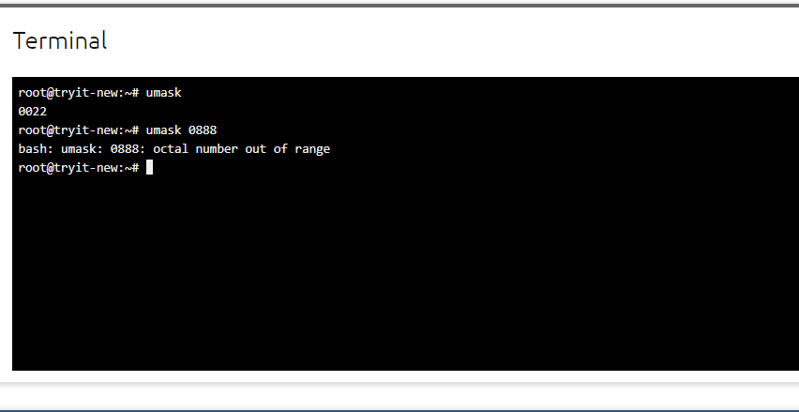

● How to add a new user with a Unique user id (e.g 1345) & check out the uniqueId of that user.

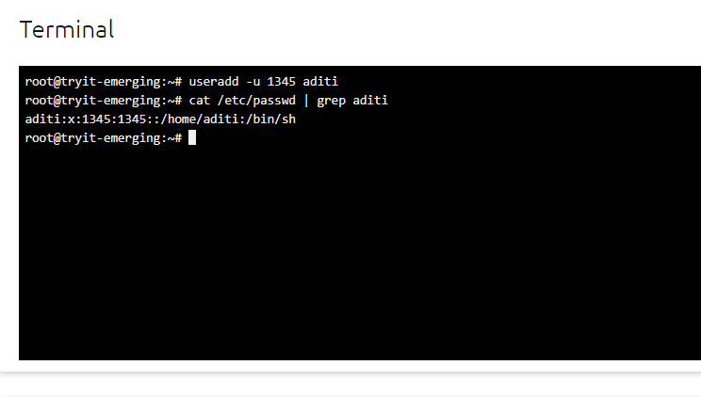

● How to change the group of any folder

To change the group ownership of a file or directory invoke the chgrp command followed by the new group name and the target file as arguments.

For example, to change the group of the file file1 to regex you would run:

chgrp regex file1

○ After this checkout the group name of the files present in that folder.

For checking the group name we will use this command :

ls –l <file name>

This will print the file name, access mode and group name.

○ Try to change the group of the folder & the files present in the same folder using a single command.

The chgrp command takes the following form:

chgrp GROUP FILE(S)…

GROUP, name of the new group or the group ID (GID). Numeric GID must be prefixed with the + symbol. FILE(s), name of one or more files.

**Assignment 3:**

● Create & compress the file with bzip2.

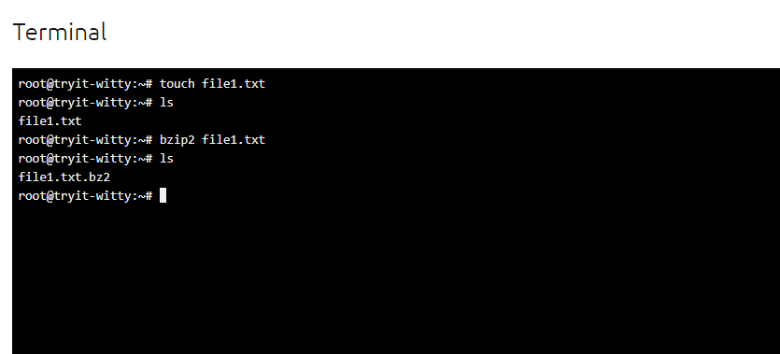

● What should be the argument to be given to unzip that file.

bzip2 -d <filename>.bz2; where -d specifies Decompress

● Read a file & show the data on terminal using file input & output redirection

cat < <filename>

● How to change the shell of user to “/bin/sh” at the time of adding the user

useradd -s /bin/sh <username>